**There is a difference between chemical and biological fridges.**

**Rough Draft For Primary Screening**

4:56PM BC 11-20-23

| **Status Detector/Sensor** | **Notification** |
| --- | --- |
| Laser | Digital -> Notification/App |
| Magnetic | Sound Alarm |
| PinPad | No Digital/Alarm |
| Wire |  |
| Heat/Cool |  |
| Card |  |

Need Requirements -> change the need requirements of digital (since the digital need is solution based)

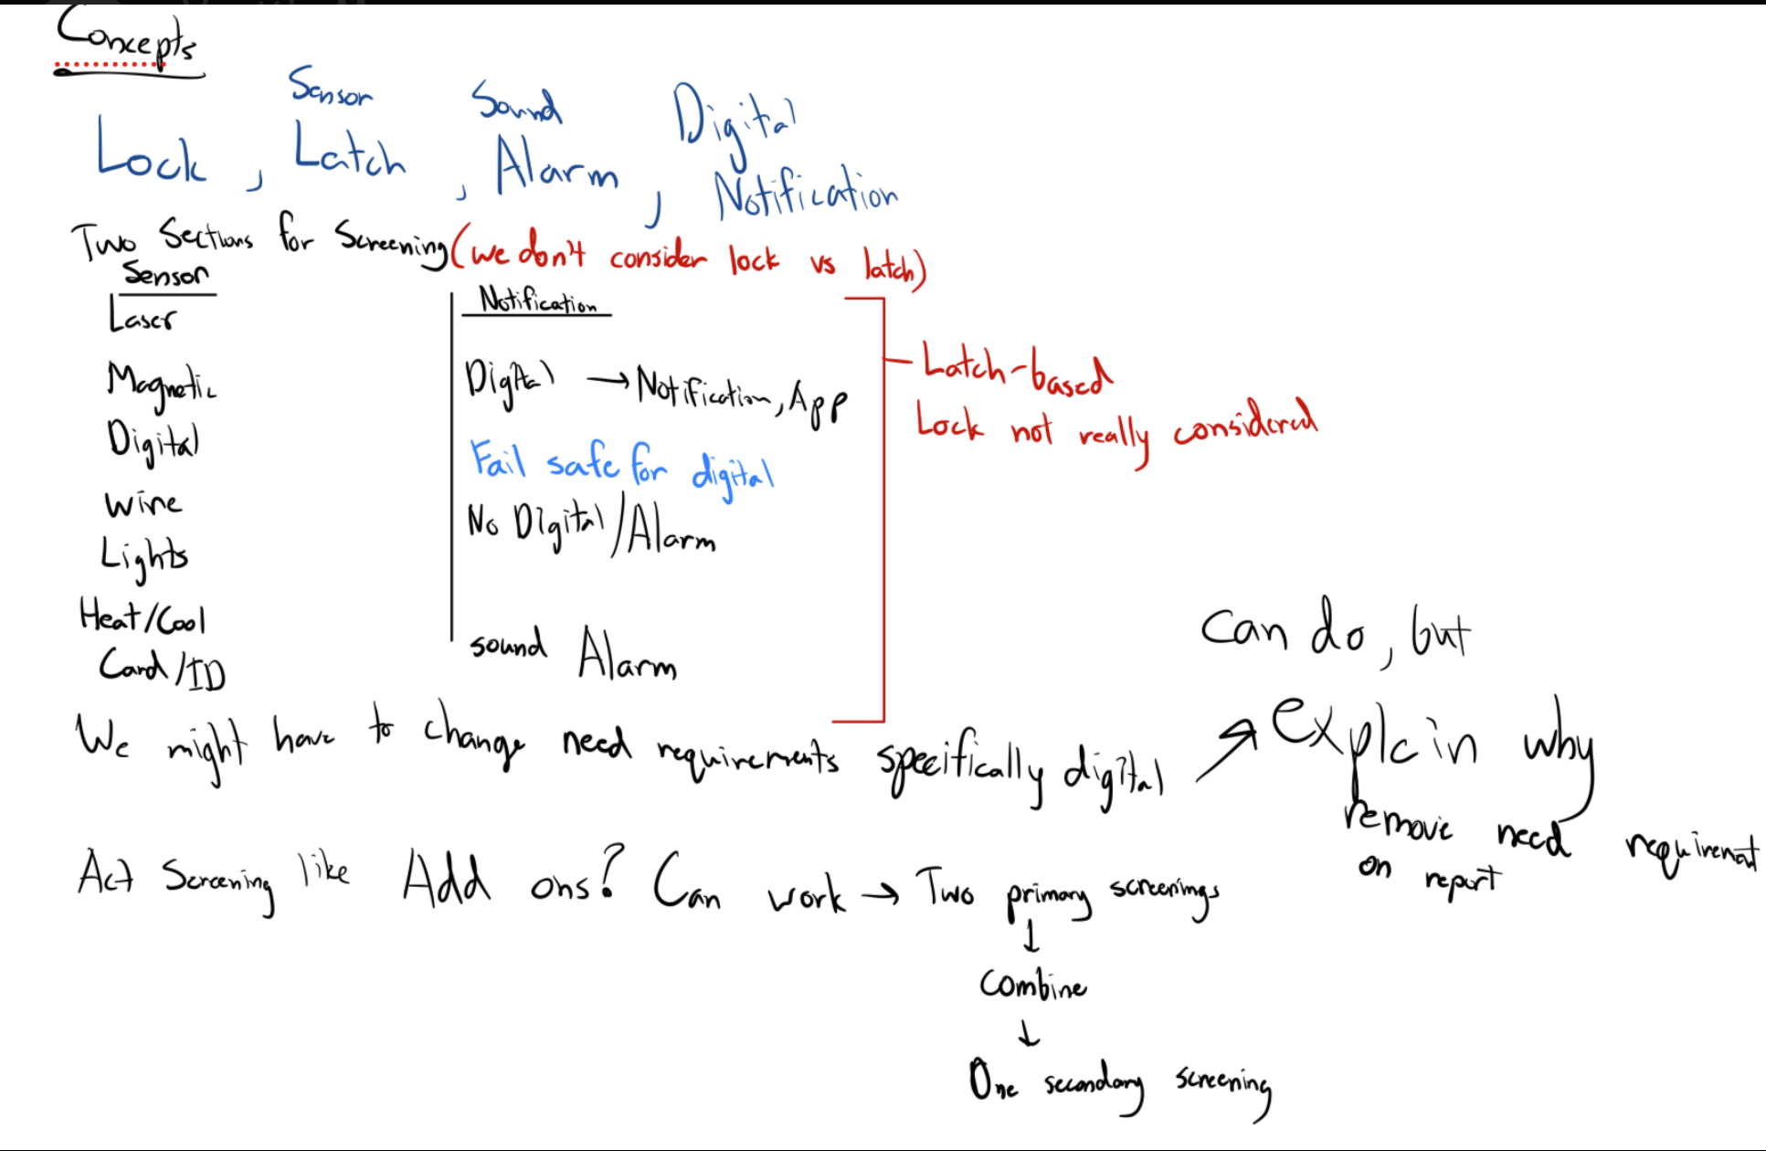

5:00PM 11-20-23 BC

Note for Adam

Met with client, client was not initially satisfied with a lower security option. We found that the reason for this was because the client is mostly focused on the -80C fridges in his biological lab, which hold VERY valuable items that denature easily. Additionally, and most importantly to the source of the disconnect, the fridges that are intended to be locked are not opened frequently.

A second point that’s less important is that the client wants people to be held accountable for forgetting to close the door, which felt a bit punitive so we redirected him towards something that more alerted people immediately so that they’d close the door.

We also discussed some ideas with him and he found our early concepts favorable.

Biggest take-away is that we probably have to either send a different survey, send the survey towards specifically people with these higher security fridges, or most likely both.

10:03AM 11-21-23 BC

-worked on survey

-what do you store inside your lab refrigerators (make it a free response)?  
-What temperature is most commonly used in the lab refrigerators in the labs that you work in?

-How is the internet or any remote connectivity in your lab (i.e. Can you text without issues in your lab?)

-created from(What would be some issues with network connection where the refrigerators are stored? Clarify. Relate to “would you have issues connecting to the internet in this area”)

-two sensors idea and separate the sensors (card identification as a sensor and writing it down on an app)